**Python program**

**Q.2) Write code to find the average of ‘n’ numbers entered by the user to function avg ( ).**

Ex: avg (10, 20, 30, 40) => average is: 70

avg (5, 10, 15) => average is: 10

**program:**

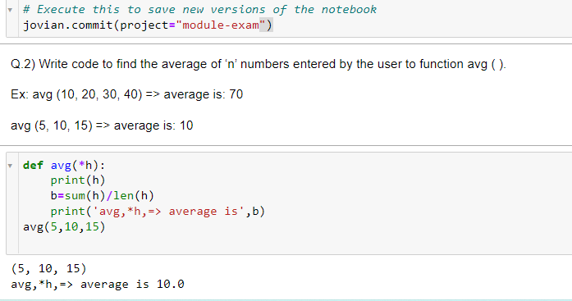

def avg(*h):

print(h)

b=sum(h)/len(h)

print('avg,*h,=> average is',b)

avg(10,20,30,40)

**ans:**

(10, 20, 30, 40)

avg,*h,=> average is 25.0

**Q.3) Print**

**1**

**0 1**

**0 1 0**

**1 0 1 0**

**1 0 1 0 1**

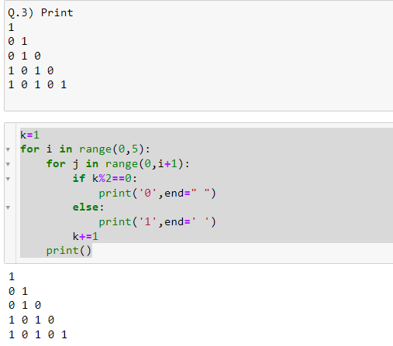

**Program:**

k=1

for i in range(0,5):

for j in range(0,i+1):

if k%2==0:

print('0',end=" ")

else:

print('1',end=' ')

k+=1

print()

**ans:**

1

0 1

0 1 0

1 0 1 0

1 0 1 0 1

**Q.5) Create class**

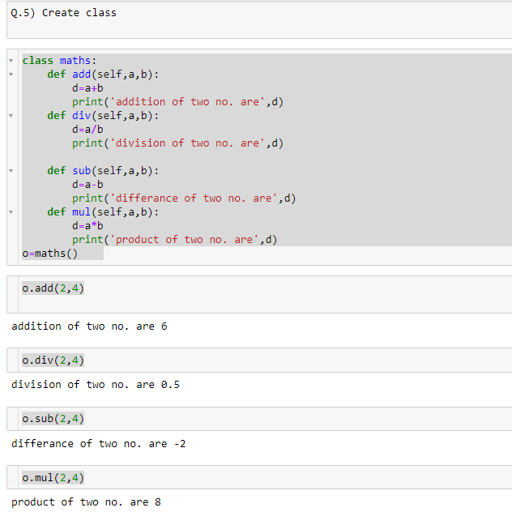

**Program:**

class maths:

def add(self,a,b):

d=a+b

print('addition of two no. are',d)

def div(self,a,b):

d=a/b

print('division of two no. are',d)

def sub(self,a,b):

d=a-b

print('differance of two no. are',d)

def mul(self,a,b):

d=a*b

print('product of two no. are',d)

o=maths()

**o.add(2,4)**

addition of two no. are 6

**o.div(2,4)**

division of two no. are 0.5

**o.sub(2,4)**

differance of two no. are -2

**o.mul(2,4)**

product of two no. are 8

**Q.7) Convert Paise in Rupees & Paises Ex: 350 is 3 Rupees 50 Paise 3.50 print Rupees: 3 Paise: 50**

**Program:**

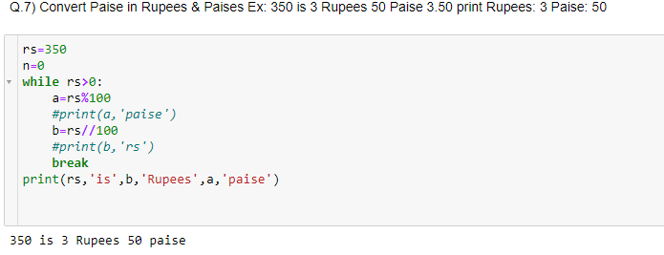

rs=350

n=0

while rs>0:

a=rs%100

#print(a,'paise')

b=rs//100

#print(b,'rs')

break

print(rs,'is',b,'Rupees',a,'paise')

**ans:**

350 is 3 Rupees 50 paise

**Q.8) Print**

**1**

**3 3**

**5 5 5**

**6 6 6 6**

**7 7 7 7 7**

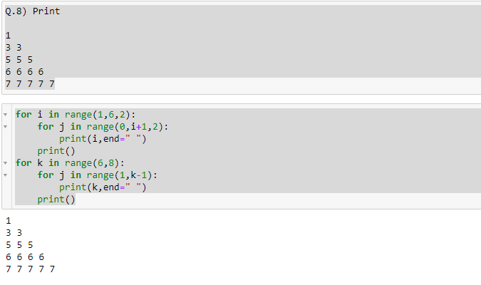

**Program:**

for i in range(1,6,2):

for j in range(0,i+1,2):

print(i,end=" ")

print()

for k in range(6,8):

for j in range(1,k-1):

print(k,end=" ")

print()

ans:

1

3 3

5 5 5

6 6 6 6

7 7 7 7 7

**Q.9) Accept String & print only alternate characters on a string.**

**Ex: this i s a _ test**

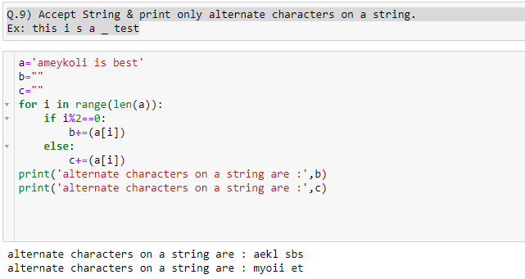

**Program:**

a='ameykoli is best'

b=""

c=""

for i in range(len(a)):

if i%2==0:

b+=(a[i])

else:

c+=(a[i])

print('alternate characters on a string are :',b)

print('alternate characters on a string are :',c)

ans:

alternate characters on a string are : aekl sbs

alternate characters on a string are : myoii et

**R Programming**

**Write a R program to create a sequence of numbers from 20 to 50 and**

**find the mean**

**of numbers from 20 to 60 and sum of numbers from 51 to 91.**

> seq(20,50)

[1] 20 21 22 23 24 25 26 27 28 29 30 31 32 33 34 35 36 37 38 39 40 41 42

[24] 43 44 45 46 47 48 49 50

> mean(20:60)

[1] 40

>

> sum(51:91)

[1] 2911

**Write a R program to print the numbers from 1 to 100 and print "Fizz" for multiples**

**of 3, print "Buzz" for multiples of 5, and print "FizzBuzz" for multiples of both.**

**for (i in 1:100) {**

**if (n%%3==0 & n%%5==0) {print('FizzBuzz')}**

**else if (n%%3==0) {print('Fizz')}**

**else if (n%%5==0) {print('Buzz')}**

**else print(n)**

**}**

**Program:**

for (n in 1:100) {

if (n%%3==0 & n%%5==0) {print('FizzBuzz')}

else if (n%%3==0) {print('Fizz')}

else if (n%%5==0) {print('Buzz')}

else print(n)

}

[1] 1

[1] 2

[1] "Fizz"

[1] 4

[1] "Buzz"

[1] "Fizz"

[1] 7

[1] 8

[1] "Fizz"

[1] "Buzz"

[1] 11

[1] "Fizz"

[1] 13

[1] 14

[1] "FizzBuzz"

[1] 16

[1] 17

[1] "Fizz"

[1] 19

[1] "Buzz"

[1] "Fizz"

[1] 22

[1] 23

[1] "Fizz"

[1] "Buzz"

[1] 26

[1] "Fizz"

[1] 28

[1] 29

[1] "FizzBuzz"

[1] 31

[1] 32

[1] "Fizz"

[1] 34

[1] "Buzz"

[1] "Fizz"

[1] 37

[1] 38

[1] "Fizz"

[1] "Buzz"

[1] 41

[1] "Fizz"

[1] 43

[1] 44

[1] "FizzBuzz"

[1] 46

[1] 47

[1] "Fizz"

[1] 49

[1] "Buzz"

[1] "Fizz"

[1] 52

[1] 53

[1] "Fizz"

[1] "Buzz"

[1] 56

[1] "Fizz"

[1] 58

[1] 59

[1] "FizzBuzz"

[1] 61

[1] 62

[1] "Fizz"

[1] 64

[1] "Buzz"

[1] "Fizz"

[1] 67

[1] 68

[1] "Fizz"

[1] "Buzz"

[1] 71

[1] "Fizz"

[1] 73

[1] 74

[1] "FizzBuzz"

[1] 76

[1] 77

[1] "Fizz"

[1] 79

[1] "Buzz"

[1] "Fizz"

[1] 82

[1] 83

[1] "Fizz"

[1] "Buzz"

[1] 86

[1] "Fizz"

[1] 88

[1] 89

[1] "FizzBuzz"

[1] 91

[1] 92

[1] "Fizz"

[1] 94

[1] "Buzz"

[1] "Fizz"

[1] 97

[1] 98

[1] "Fizz"

[1] "Buzz"